**Analysis 2 Report**

**1.Can you tell me No of Vehicles by Brand Available on Ebay for sale with the help of visualization.**

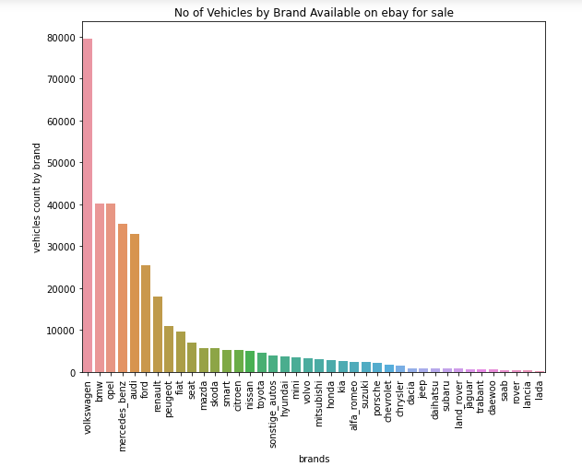

Volkswagen brand vehicles are most available vehicles with a count of 79640 are available for sale on Ebay. And lada is the least available brand on Ebay for sale.

**2. What is the Average price for vehicles based on the type of vehicle as well as on the type of gearbox. Explain me with both numerical and visualization analysis.**

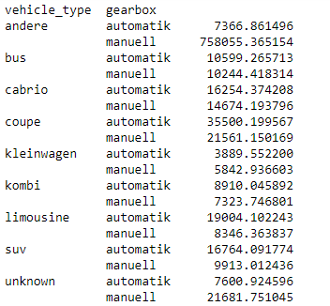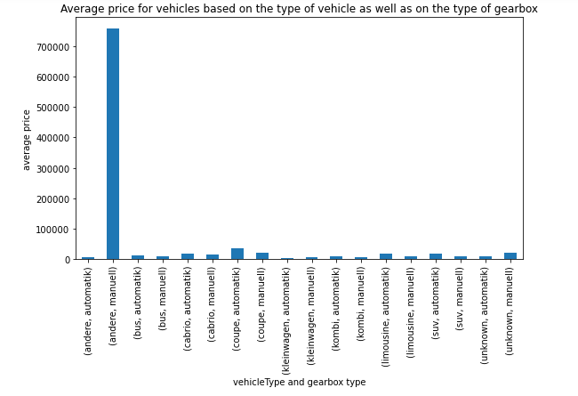

vehicle type of Andere with manual gearbox has the highest average price.

**3. What is the marginal probability of private seller**

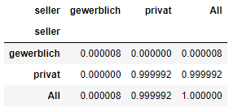

The Marginal probability that the seller is private is 0.999. which means the seller on ebay is private seller .